Koneru Lakshmaiah Education Foundation
(Deemed to be University)

FRESHMAN ENGINEERING DEPARTMENT

A Project Based Lab Report On

SMART HEALTH AND MEDICAL HISTORY TRACKER+WELLNESS ANALYTICS SYSTEM

SUBMITTED BY:
ID NUMBER | NAME
2500032675 | Yathati Shiny
2500032744 | Roopaswini Pesara
2500040008 | Talamala Ashrita
2500040240 | Guduru Jagadeesh

Under the guidance of
Dr E. Sreedevi
Professor, C.S.E



KL UNIVERSITY
Green fields, Vaddeswaram – 522 502
Guntur Dt., AP, India.

DEPARTMENT OF BASIC ENGINEERING SCIENCES-1



CERTIFICATE

This is to certify that the project based laboratory report entitled “SMART HEALTH AND MEDICAL HISTORY TRACKER+WELLNESS ANALYTICS SYSTEM” submitted by YATHATI SHINY, ROOPASWINI PESARA, TALAMALA ASHRITA, GUDURU JAGADEESH bearing Regd. No. 2500032675, 2500032744, 2500040008, 2500040240 to the Department of COMPUTER SCIENCE ENGINEERING , KL University in partial fulfillment of the requirements for the completion of a project based Laboratory in “PYTHON PROGRAMMING (25SC2007)” course in I B Tech II Semester, is a Bonafide record of the work carried out by them under my supervision during the academic year 2025 – 2026.

Dr E Sreedevi Dr. D. HARITHA
PROJECT SUPERVISOR HEAD OF THE DEPARTMENT

ACKNOWLEDGEMENTS

It is great pleasure for me to express my gratitude to our honorable President. Sri. Koneru Satyanarayana, for giving the opportunity and platform with facilities in accomplishing the project-based laboratory report.
We express sincere gratitude to our Director Dr. A. Jagdeesh for his administration towards our academic growth. We express sincere gratitude to our Principal Dr. V. Krishna Reddy for his administration towards our academic growth.
We express sincere gratitude to our HOD-BES-1 Dr. D. Haritha for her leadership and constant motivation provided for the successful completion of our academic semester. We record it as my privilege to deeply thank you for providing us with the efficient faculty and facilities to make our ideas into reality.
We express our sincere thanks to our project supervisor Dr E Sreedevi for her novel association of ideas, encouragement, appreciation, and intellectual zeal which motivated us to venture this project successfully.
Finally, we are pleased to acknowledge our indebtedness to all those who devoted themselves directly or indirectly to making this project a success.

Yathati Shiny (2500032675)
Roopaswini Pesara (2500032744)
Talamala Ashrita (2500040008)
Guduru Jagadeesh (2500040240)

ABSTRACT
The project titled “Smart Health and Medical History Tracker + Wellness Analytics System” focuses on developing a comprehensive digital platform that allows users to securely manage their personal health records while also gaining meaningful insights into their overall wellness. This system aims to centralize medical data such as prescriptions, lab reports, diagnoses, and doctor consultations into a single, easily accessible interface. By leveraging modern web technologies, the platform ensures that users can access their medical history anytime and from anywhere, enabling better continuity of care and improved communication with healthcare providers.
In addition to record management, the system incorporates advanced wellness analytics features that help users monitor key health indicators such as physical activity, diet patterns, sleep cycles, and vital statistics. By analyzing this data, the platform can generate personalized health insights, trends, and recommendations to encourage healthier lifestyle choices. The integration of data visualization tools further enhances user understanding by presenting complex health information in a clear and interactive manner.
Overall, the proposed system aims to bridge the gap between traditional medical record-keeping and modern digital health solutions. It not only improves the efficiency and accessibility of health data management but also empowers individuals to take a proactive role in their well-being. With a user-friendly interface and secure data handling mechanisms, the Smart Health and Medical History Tracker serves as a reliable and scalable solution for both individuals and healthcare ecosystems.

INDEX

S.NO | TITLE | PAGE NO
1 | Introduction | 6-11
2 | Aim of the Project | 12
 | 2.1 Advantages & Disadvantages
 | 2.2 Future Implementation
3 | Software & Hardware Details | 13
4 | Flow Chart | 14
5 | Algorithm for each module | 15
6 | Implementation | 16-22
7 | Output/ Screen shots | 23-25
8 | Conclusion | 26

INTRODUCTION
In today’s modern world, maintaining personal health has become very important due to changing lifestyles and increasing health risks. However, many people still rely on traditional methods of storing medical records, which are often unorganized, difficult to maintain, and prone to loss. This creates a need for a smart and efficient system that can manage health data digitally and provide meaningful insights. The Smart Health & Medical History Tracker + Wellness Analytics System (SHM-WAS) is developed to overcome these problems by providing a complete digital solution for health monitoring and management.

The system allows users to securely register and store their personal and health-related information in a structured manner. It collects important inputs such as user ID, age, gender, height, weight, blood pressure (systolic and diastolic), heart rate, blood sugar level, daily physical activity, and sleep duration. These inputs form the basis for analyzing the user’s overall health condition.

Using these inputs, the system generates several useful outputs. It calculates Body Mass Index (BMI) and categorizes it into underweight, normal, or overweight. It also determines blood pressure status, diabetes risk level, heart health status, physical activity level, and sleep quality analysis. Based on these parameters, the system computes an overall wellness score, which gives a summary of the user’s health condition. Additionally, the system generates health alerts whenever abnormal values are detected and provides suitable health recommendations to improve the user’s lifestyle.

The project is implemented using Python programming language and follows object-oriented programming concepts such as classes and inheritance. A base class is used to represent general user information, and a derived class is used to handle patient-specific health data. This approach improves code organization and reusability. The system also uses file handling techniques to store user data in CSV files, ensuring that the information is maintained for future reference.

To handle and process the stored data efficiently, the system makes use of powerful libraries such as Pandas and NumPy. Pandas is used for managing structured data and reading/writing files, while NumPy is used for performing numerical calculations such as averages. For better understanding and visualization of health data, Matplotlib is used to generate graphs that display trends in parameters like BMI, blood pressure, and sugar levels.

Exception handling is also implemented in the system to manage errors and invalid inputs, ensuring smooth execution without crashes. In addition, user data security is maintained using password encryption techniques, which protect sensitive information from unauthorized access.

Overall, the Smart Health & Medical History Tracker + Wellness Analytics System is a comprehensive application that integrates data collection, storage, analysis, and visualization. It helps users monitor their health regularly and take preventive measures based on system-generated insights. The project demonstrates how programming concepts and data analytics can be combined to create a practical and user-friendly health management solution.

In addition to basic health tracking, the system focuses on providing a detailed analysis of multiple health parameters to give a complete understanding of an individual’s wellness. Each input parameter plays a significant role in determining the overall health condition. For example, body weight and height are used to calculate Body Mass Index (BMI), which is an important indicator of whether a person is underweight, normal, or overweight. Similarly, blood pressure values help in identifying hypertension risks, while blood sugar levels are useful in assessing diabetes risk.

Heart rate is another important parameter included in the system, as it indicates the condition of the cardiovascular system. Daily physical activity, measured through steps or exercise duration, helps in understanding whether the user maintains an active lifestyle. Sleep duration is also considered, as proper sleep is essential for both physical and mental health. By combining all these inputs, the system ensures a comprehensive health

evaluation rather than focusing on a single parameter.

The outputs generated by the system are designed to be simple and easy to understand for users. Instead of displaying only raw values, the system interprets the data and provides meaningful conclusions such as BMI category, blood pressure status, diabetes risk level, and heart health condition. This makes it easier for users to understand their health condition without requiring medical expertise.

One of the most important features of this system is the overall wellness score. This score is calculated based on different health parameters and gives a quick summary of the user’s health condition. It helps users to easily identify whether their health is in a good state or requires improvement. This feature adds significant value to the system by providing a single measure that represents overall wellness.

The system also includes a health alert mechanism that notifies users when any parameter goes beyond normal limits. For example, if the BMI is too high, the system generates an alert indicating overweight condition. Similarly, alerts are generated for high blood pressure, high sugar levels, or poor sleep quality. These alerts act as early warnings and encourage users to take preventive actions before the condition becomes severe.

Along with alerts, the system provides basic health recommendations. These recommendations may include suggestions such as improving diet, increasing physical activity, maintaining regular exercise, and getting proper sleep. Although these recommendations are simple, they play an important role in guiding users towards a healthier lifestyle.

From a technical perspective, the system demonstrates the effective use of various programming concepts. Object-oriented programming is used to structure the system efficiently, where classes and inheritance improve modularity and code reusability. File handling techniques are used to store user data permanently in CSV format, making it easy to retrieve and update information. Exception handling ensures that the system can handle invalid inputs and errors without crashing.

The use of data analysis libraries such as Pandas and NumPy enhances the system’s ability to process large amounts of data efficiently. Pandas provides powerful data structures for handling tabular data, while NumPy enables fast numerical computations. Matplotlib is used to visualize the data through graphs, which helps users understand patterns and trends more clearly.

Furthermore, the system ensures basic security by encrypting user passwords using hashing techniques. This prevents unauthorized access and protects user data, which is an important aspect of any health-related application.

In conclusion, the Smart Health & Medical History Tracker + Wellness Analytics System not only simplifies health record management but also provides intelligent insights into personal health. It combines data storage, analysis, visualization, and alert mechanisms into a single platform. The system can be further enhanced in the future by integrating advanced technologies such as mobile applications, cloud storage, and artificial intelligence for predictive health analysis.
Health monitoring systems have become increasingly important in recent years due to the rise in lifestyle-related diseases such as obesity, diabetes, hypertension, and heart problems. Many of these health conditions develop gradually and may not show immediate symptoms. Therefore, regular monitoring of health parameters is necessary to detect potential risks at an early stage. Digital health systems help individuals keep track of their health conditions and maintain proper medical records in an organized manner.

The Smart Health & Medical History Tracker + Wellness Analytics System is designed to provide a user-friendly platform that allows individuals to monitor their health efficiently. The system collects multiple health-related inputs such as age, gender, height, weight, blood pressure, heart rate, blood sugar level, daily physical activity, and sleep duration. These parameters are essential indicators of a person’s physical well-being and provide valuable information about their lifestyle habits.

One of the main objectives of this system is to transform raw health data into meaningful insights. Instead of simply storing the information, the system analyzes the data and

produces useful outputs that help users understand their health condition better. For instance, the Body Mass Index (BMI) is calculated using height and weight values. BMI is widely used in the medical field to determine whether a person has a healthy body weight relative to their height.

Similarly, blood pressure values are analyzed to determine whether the user has normal blood pressure or is at risk of hypertension. Blood sugar levels are used to assess diabetes risk, which is one of the most common chronic diseases worldwide. Heart rate is also evaluated to check whether it falls within the normal range, which indicates proper functioning of the cardiovascular system.

Physical activity and sleep patterns are also important aspects of overall health. The system analyzes the number of daily steps or exercise duration to determine the user’s physical activity level. A person who maintains regular physical activity is more likely to maintain good health compared to someone with a sedentary lifestyle. Sleep duration is another key factor considered in the system, as poor sleep habits can lead to various health problems including stress, fatigue, and reduced productivity.

The wellness analytics feature of the system combines all these health parameters to provide a comprehensive overview of the user’s health status. By evaluating multiple indicators together, the system calculates an overall wellness score that summarizes the user’s health condition. This score helps users easily understand whether their health is in a good state or if improvements are required.

Another important component of the system is the health alert mechanism. Whenever the system detects abnormal values, such as high BMI, high blood pressure, or high blood sugar levels, it generates warning messages to inform the user. These alerts encourage users to take preventive measures such as improving their diet, exercising regularly, or consulting a healthcare professional.

In addition to textual outputs, the system also provides graphical visualization of health data. Graphs generated using visualization libraries allow users to observe patterns and

trends in their health parameters over time. Visual representation makes the information easier to understand compared to plain numerical values and helps users monitor their progress effectively.

The project also demonstrates the practical application of several programming and data analysis concepts. It integrates object-oriented programming, file handling, exception handling, and data visualization techniques into a single system. By combining these technologies, the project provides both functional and educational value, making it a useful learning experience for understanding how software can be applied in the healthcare domain.
Furthermore, the system is designed to be flexible and expandable. In the future, additional features such as hospital visit tracking, medical history storage, doctor appointment scheduling, and cloud-based data storage can be integrated into the system.

These enhancements can transform the application into a more advanced health management platform.
Overall, this project highlights the importance of using digital technology to support personal healthcare management. By providing an organized platform for storing and analyzing health data, the system empowers users to take control of their health and make informed lifestyle decisions.

AIM

The aim of the Smart Health & Medical History Tracker + Wellness Analytics System (SHM-WAS) is to develop a Python-based application that enables users to store, manage, and track their medical records digitally. The system focuses on organizing important health information such as medical history, medications, and health parameters in a structured way. It also aims to provide basic analytics to help users understand their health trends, thereby supporting better health monitoring and decision-making.

ADVANTAGES

Provides easy access to medical records anytime

Reduces paperwork and manual record keeping

Helps in tracking health conditions over time

Saves time during emergencies or doctor visits

Simple and user-friendly system

DISADVANTAGES
- Requires basic computer knowledge to use
- Data security may be a concern
- Limited features compared to advanced medical systems
- Not directly connected to hospitals

FUTURE IMPLEMENTATION
- Can be developed into a mobile application
- Integration with hospitals and clinics
- Cloud storage for better data safety
- Adding AI-based health analysis features
- Reminder system for medicines and checkups

SYSTEM REQUIREMENTS

SOFTWARE REQUIREMENTS:
- Operating System: Windows / Linux / macOS
- Programming Language: Python
- IDE: PyCharm / Visual Studio Code / IDLE
- Libraries: Pandas, Matplotlib, Tkinter
- Database: SQLite / MySQL / File Handling

HARDWARE REQUIREMENTS:
- Processor: Intel i3 or above
- RAM: Minimum 4 GB
- Storage: At least 500 MB free space
- System Type: 64-bit computer

FLOW CHART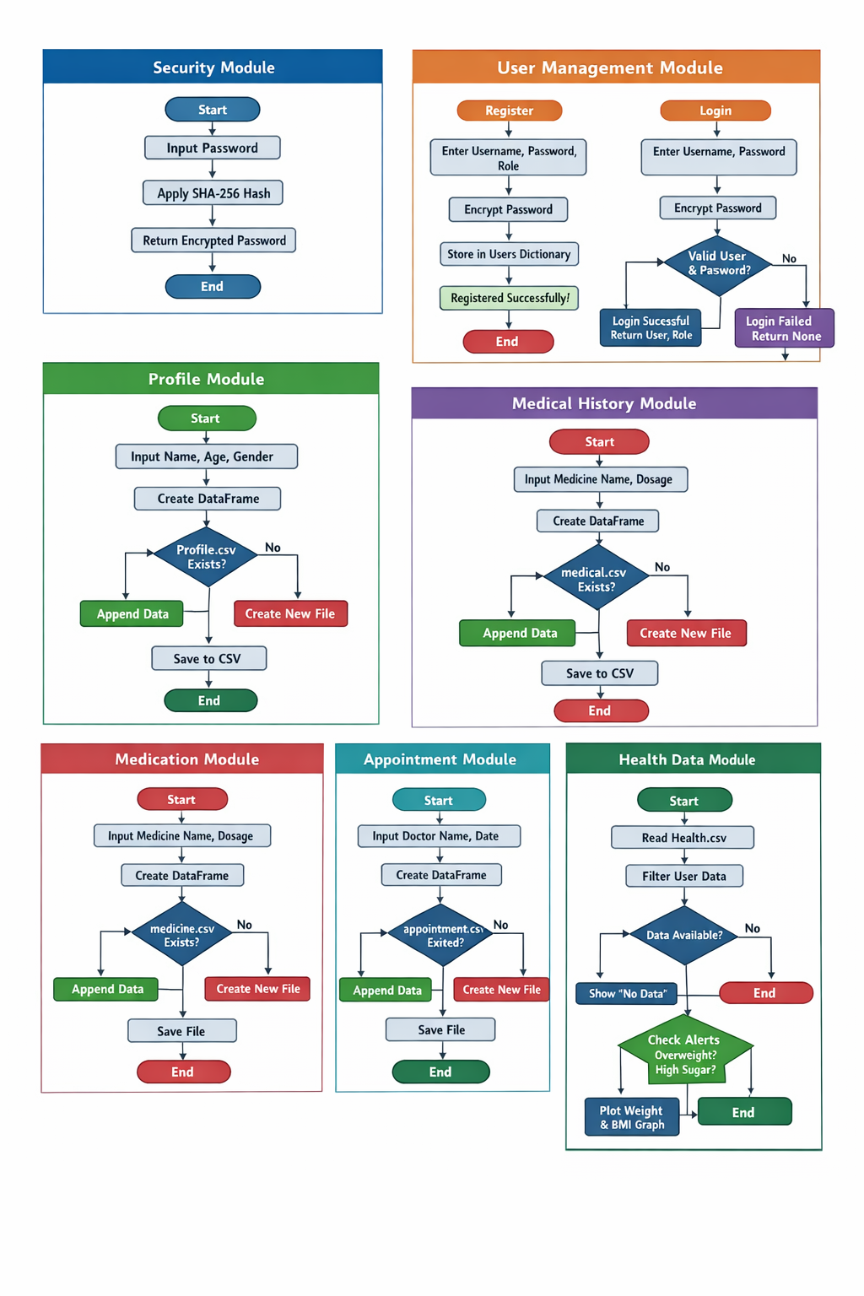

ALGORITHM

1. SECURITY MODULE (Encryption)
Algorithm:
- Start
- Input password
- Convert password to encoded format
- Apply SHA-256 hashing
- Store encrypted password
- Return encrypted value
- End

2. USER MANAGEMENT MODULE

(a) Register Algorithm
- Start
- Input username, password, role
- Encrypt password
- Store (username, encrypted password, role) in dictionary
- Display success message
- End

(b) Login Algorithm
- Start
- Input username and password
- Encrypt entered password
- Check if username exists
- If exists, compare stored password with encrypted password
- If match → login success, return user and role
- Else → display login failed
- End

3. PROFILE MODULE
Algorithm:
- Start
- Input name, age, gender
- Create a data table (DataFrame)
- Check if profile.csv exists
- If exists → read old data and append new data
- Else → create new file
- Save data into CSV file
- Display confirmation message
- End

4. MEDICAL HISTORY MODULE
Algorithm:
- Start
- Input illness, allergy, surgery, prescription
- Create DataFrame
- Check if medical.csv exists
- If yes → append data
- Else → create new file
- Save data
- Display message
- End

5. MEDICATION MODULE
Algorithm:
- Start
- Input medicine name and dosage
- Create DataFrame
- Check if medicine.csv exists
- If yes → append
- Else → create new file
- Save data
- Display confirmation
- End

6. APPOINTMENT MODULE
Algorithm:
- Start
- Input doctor name and date
- Create DataFrame
- Check if appointment.csv exists
- If yes → append
- Else → create new file
- Save data
- Display confirmation
- End

7. HEALTH DATA MODULE (Patient Class)
Algorithm:
- Start
- Input weight, height, sugar level
- Validate input (handle errors)
- Calculate BMI = weight / (height × height)
- Create DataFrame
- Check if health.csv exists
- If yes → append data
- Else → create new file
- Save data
- Display confirmation
- End

8. ANALYTICS MODULE
Algorithm:
- Start
- Read health.csv
- Filter data for current user
- Check if data is empty
- If empty → display “No data” and stop
- Else → calculate average BMI and sugar
- Display results
- If BMI > 25 → show overweight alert
- If sugar > 180 → show high sugar alert
- Plot graph (Weight vs BMI)
- End

9. MAIN MODULE (CONTROL SYSTEM)
Algorithm:
- Start
- Initialize current_user = None
- Display menu options
- Input user choice
- If choice = 1 → call register()
- If choice = 2 → call login()
- If logged in:
  - 3 → add profile
  - 4 → add medical history
  - 5 → add medication
  - 6 → add appointment
  - 7 → add health data
  - 8 → analyze data
- If choice = 9 → exit program
- Else → display “Login first”
- Repeat loop
- End

IMPLEMENTATION

import hashlib
import pandas as pd
import numpy as np
import matplotlib.pyplot as plt
# ---------------- SECURITY ----------------
users = {} # username: (password, role)
def encrypt(password):
return hashlib.sha256(password.encode()).hexdigest()
# ---------------- USER MANAGEMENT ----------------
def register():
u = input("Username: ")
p = input("Password: ")
role = input("Role (admin/patient): ")
users[u] = (encrypt(p), role)
print("Registered successfully!")
def login():
u = input("Username: ")
p = input("Password: ")
if u in users and users[u][0] == encrypt(p):
print("Login successful!")
return u, users[u][1]
else:
print("Login failed!")
return None, None
# ---------------- PROFILE ----------------
def add_profile(u):
name = input("Name: ")
age = int(input("Age: "))
gender = input("Gender: ")
df = pd.DataFrame([[u, name, age, gender]],
columns=["User","Name","Age","Gender"])
try:
old = pd.read_csv("profile.csv")
df = pd.concat([old, df])
except:
pass
df.to_csv("profile.csv", index=False)
print("Profile saved!")
# ---------------- MEDICAL HISTORY ----------------
def add_medical(u):
illness = input("Illness: ")
allergy = input("Allergy: ")
surgery = input("Surgery: ")
prescription = input("Prescription: ")
df = pd.DataFrame([[u, illness, allergy, surgery, prescription]],
columns=["User","Illness","Allergy","Surgery","Prescription"])
try:
old = pd.read_csv("medical.csv")
df = pd.concat([old, df])
except:
pass
df.to_csv("medical.csv", index=False)
print("Medical history saved!")
# ---------------- MEDICATION & APPOINTMENT ----------------
def add_medication(u):
med = input("Medicine Name: ")
dose = input("Dosage: ")
df = pd.DataFrame([[u, med, dose]],
columns=["User","Medicine","Dosage"])
try:
old = pd.read_csv("medicine.csv")
df = pd.concat([old, df])
except:
pass
df.to_csv("medicine.csv", index=False)
print("Medication added!")
def add_appointment(u):
doctor = input("Doctor: ")
date = input("Date: ")
df = pd.DataFrame([[u, doctor, date]],
columns=["User","Doctor","Date"])
try:
old = pd.read_csv("appointment.csv")
df = pd.concat([old, df])
except:
pass
df.to_csv("appointment.csv", index=False)
print("Appointment saved!")
# ---------------- OOP ----------------
class Person:
def __init__(self, username):
self.username = username
class Patient(Person):
def add_health(self):
try:
weight = float(input("Weight: "))
height = float(input("Height: "))
sugar = int(input("Sugar: "))
bmi = round(weight/(height*height),2)
df = pd.DataFrame([[self.username, weight, bmi, sugar]],
columns=["User","Weight","BMI","Sugar"])
try:
old = pd.read_csv("health.csv")
df = pd.concat([old, df])
except:
pass
df.to_csv("health.csv", index=False)
print("Health data saved!")
except:
print("Invalid input!")
# ---------------- ANALYTICS ----------------
def analyze(u):
try:
df = pd.read_csv("health.csv")
data = df[df["User"] == u]
if data.empty:
print("No data!")
return
avg_bmi = np.mean(data["BMI"])
avg_sugar = np.mean(data["Sugar"])
print("Average BMI:", round(avg_bmi,2))
print("Average Sugar:", round(avg_sugar,2))
# Alerts
if avg_bmi > 25:
print("⚠ Overweight")
if avg_sugar > 180:
print("⚠ High Sugar")
# Graph
data[["Weight","BMI"]].plot()
plt.title("Health Trends")
plt.show()
except:
print("Error!")
# ---------------- MAIN ----------------
current_user = None
role = None
while True:
print("\n--- HEALTH SYSTEM ---")
print("1.Register")
print("2.Login")
print("3.Profile")
print("4.Medical History")
print("5.Medication")
print("6.Appointment")
print("7.Health Data")
print("8.Analysis")
print("9.Exit")
ch = input("Choice: ")
if ch == "1":
register()
elif ch == "2":
current_user, role = login()
elif ch == "3" and current_user:
add_profile(current_user)
elif ch == "4" and current_user:
add_medical(current_user)
elif ch == "5" and current_user:
add_medication(current_user)
elif ch == "6" and current_user:
add_appointment(current_user)
elif ch == "7" and current_user:
p = Patient(current_user)
p.add_health()
elif ch == "8" and current_user:
analyze(current_user)
elif ch == "9":
break
else:
print("Login first!")

OUTPUT SCREEN SHOTS
Screen Shots:

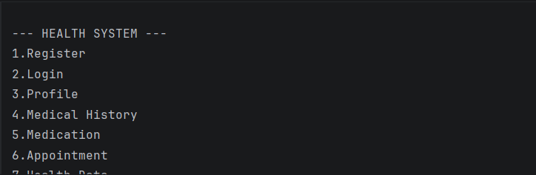

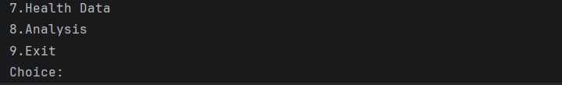
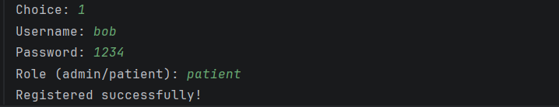

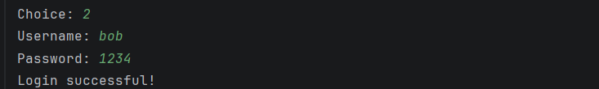

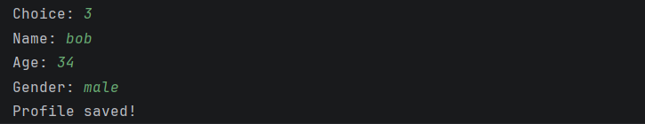

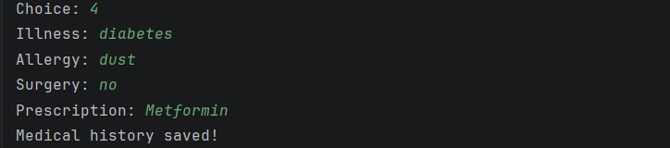

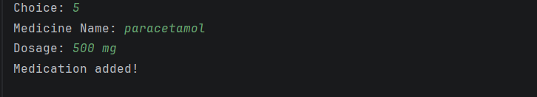

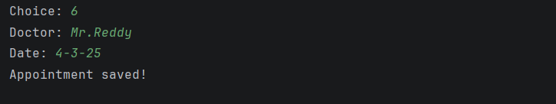

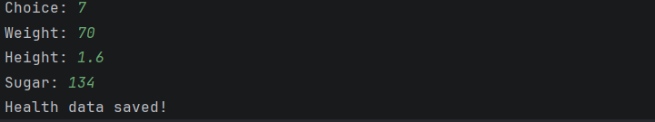
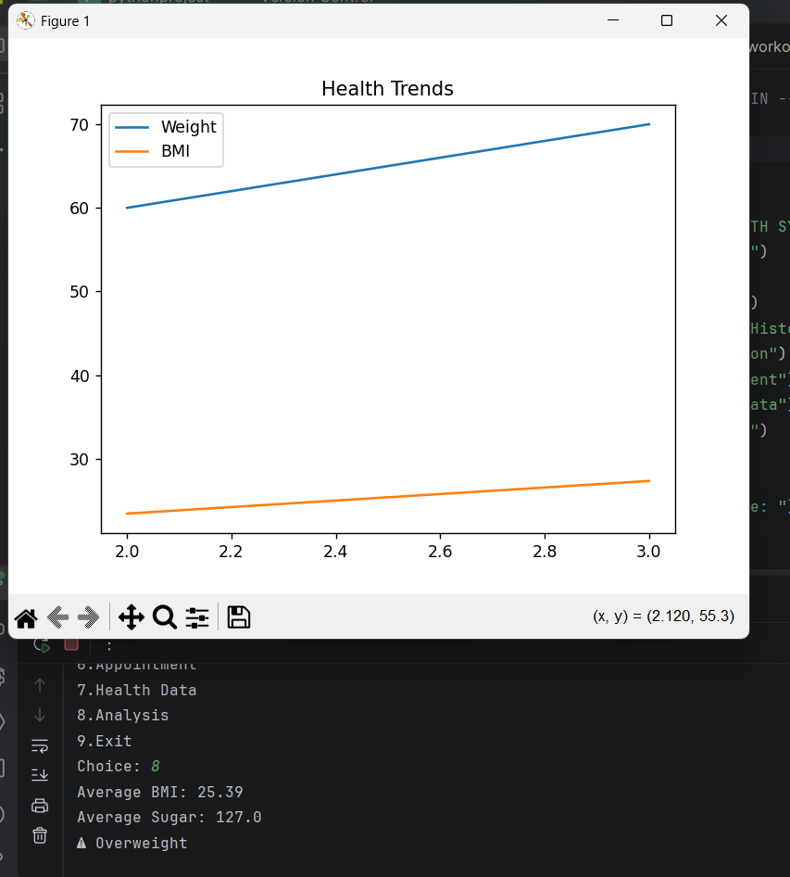

CONCLUSION
The Smart Health & Medical History Tracker + Wellness Analytics System successfully provides a comprehensive solution for managing and analyzing personal health data. The system allows users to securely register, store their health information, and track important parameters such as BMI, blood pressure, sugar levels, heart rate, physical activity, and sleep.

By using Python along with libraries like Pandas, NumPy, and Matplotlib, the project effectively demonstrates data storage, processing, and visualization. The implementation of object-oriented programming concepts such as classes and inheritance, along with file handling and exception handling, enhances the functionality and reliability of the system.

The system not only analyzes health data but also generates health alerts and provides useful recommendations, helping users maintain a better lifestyle. Overall, this project is a practical and efficient health monitoring system that can be further enhanced for real-world applications.

